JUNIPER TREE

ANNUAL REPORT 2010



Juniper Tree

Box UP379 KNUST

Kumasi, Ghana

Tel. +233 32 206 1051/+233 26 6771872

Email: junpertree.ghana@gmail.com Web: ww.junipertreeghana.org

TABLE OF CONTENTS
INTRODUCTION AND HISTORY
MISSION
VISION, SLOGAN GOALS AND CORE VALUES
STATEMENT OF BELIEF
OUR BOARD OF DIRECTORS
OVERVEIW OF 2010
PROJECTIONS FOR 2011
PROPOSED BUDGET FOR 2011
AUDITED ACCOUNTS FOR 2010

- INTRODUCTION:
We are pleased to present to you our partners the 2010 report of Juniper Tree. 2010 was the year of consolidation and launching out. We are grateful to all of you who have supported us over the past couple of years.
- WHO ARE WE? OUR HISTORY, MISSION AND CORE VALUES,OUR BOARD OF DIRECTORS
Juniper Tree is a Christian non profit, non governmental pastoral Care and Counselling organization in Ghana, West Africa. It is registered as a charity with the Social Welfare Department.
WHY THE NAME JUNIPER TREE?
In 1 Kings 19. (KJV) After going through the stress of successfully battling the prophets of Baal, Queen Jezebel sought to kill the Prophet Elijah. He fled for his life.
In the course of running away, he found a Juniper Tree. Under that tree, he cried out “Oh Lord, take away my life; for I am not better than my fathers.”
This cry from a prophet of God after a great spiritual victory is classic example of somebody who had reached a great depth of discouragement, depression and became suicidal.
However, there under the Juniper Tree, God ministered to Elijah. He was comforted, restored, and given hope. From there, full of this hope, Elijah went back to continue the task God had given him.
This is what Juniper Tree, is all about; a place where men, women and children, who are discouraged, depressed, or traumatized in any way by the adverse circumstances of life can find comfort, restoration and hope.
This is where Juniper Tree gets her inspiration.
WHAT IS OUR MISSION?
Our Mission at Juniper Tree is to be an expression of God’s Comfort, Restoration and Hope through the provision of counselling and support to a hurting world.

What is our VISION?
Juniper Tree’s vision is to provide Care-giving Centers in all the Regions of Ghana and beyond where:
- Ministers and other care-givers would find Comfort, Restoration and Hope for their hurts;
- Would-be couples and couples would receive pre- and post-marital counseling, and marriages nurtured to what God intended it to be.
- Victims and culprits of Domestic abuse would be helped to deal with the issues
- Physically and sexually abused children would be provided avenues to reach out to the only One who can Comfort, Restore and give Hope
- Teen and adolescents would receive guidance for their physical, emotional, mental and spiritual challenges
- Persons and families dealing with loss and depression would be helped to make meaning out of their situations
- Victims of chronic/terminal diseases and HIV/AIDS and their families would be helped to deal with the situation and offer the needed spiritual and emotional support
- The vulnerable would be educated and empowered to realize their God-given potentials.
What is our SLOGAN?
‘Comfort, Restoration & Hope’
What are our goals?
- To be a voice for the voiceless.
- To train others to become channels of God’s grace to the suffering in our world.
- To be a shoulder for the crying, hope and healing to the helpless.
- To provide a holistic care to all who hurt,
What are our core values?
- We seek to honor Christ in all we do
- We believe that all men and women deserve to be treated with dignity irrespective of creed and/or race.
(III) We believe that accountability and integrity are very important.
- We believe that every child is a gift from God to be loved and nurtured.
- Confidentiality is at the core of all we do.

What is our statement of Belief?
We believe in the basic doctrines of the Christian faith as codified in the Apostle’s Creed. We therefore affirm the following:
i That the Bible is the inspired and infallible word of God and our final authority in matters of faith and practice.
ii. That there is one God, eternally existent in three persons, Father, Son and Holy Spirit.
iii. That Jesus was conceived of the Holy Spirit and born of a virgin.
iv. That Jesus was the human incarnation of God and that on earth, He was fully God and fully man.
v. That salvation is through faith in Christ and Christ alone.
vi. That we are saved by grace and grace alone
vii. That Christ rose bodily from the dead
viii. That all, both the saved and the unsaved will be resurrected; the saved unto salvation and the unsaved unto damnation.
viii. That man was created in the image of God which is currently marred by sin.
ix. That through the grace of God and the enablement of the Holy Spirit man can live a godly life.
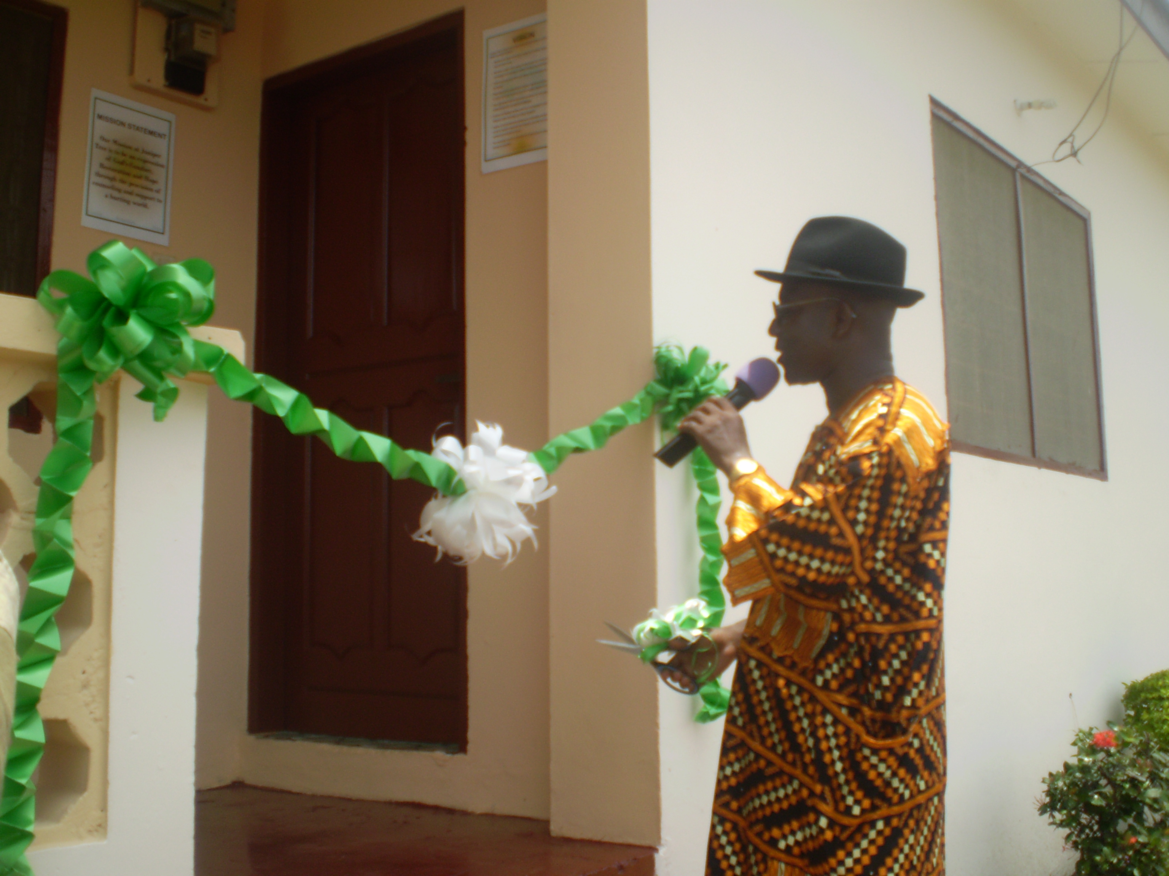

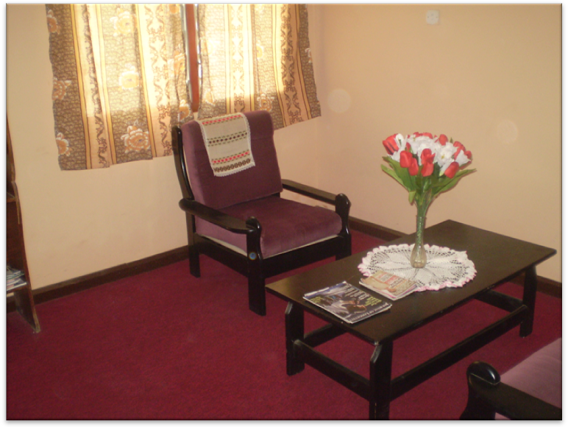

WHO ARE OUR BOARD OF DIRECTORS?
Chairman:
Dr. Victor Kpodo is a seasoned Mechanical Engineering consultant and lecturer in Mechanical Engineering at the Kwame Nkrumah University of Science and Technology. He is also the Director and Chairman of Nayra Engineering Ltd., a firm of building services engineering consultants.
Victor K. A. Kpodo obtained a Bachelor of Science degree in Mechanical Engineering from the Kwame Nkrumah University of Science and Technology (KNUST). He received his Master of Science and Doctor of Philosophy degrees in Mechanical Engineering from the University of Minnesota, USA and the University of Salford, England, respectively. His professional and teaching careers have spanned several years. Before taking up fulltime lectureship position at the Kwame Nkrumah University of Science and Technology, he had worked as a mechanical maintenance engineer at the Akosombo Generating station of the Volta River Authority (VRA). His pre-professional practice and experience span a number of organizations including Ghana Consolidated Diamond Company (formerly CAST), Public Works Department (PWD), Ghana Broadcasting Corporation (GBC), and Wood Governors, Rockford, Illinois, USA. He is a corporate member of the Ghana Institution of Engineers (MGIE)
Victor Kpodo has served as a lecturer, Head of Department and Vice-Dean of the School of Engineering (KNUST). He was appointed Head of the Kumasi campus of the University of Education, Winneba as well as the Dean of the Division of Applied Arts & Technology Education comprising four Academic Departments on three (3) campuses at Winneba, Kumasi and Mampong-Ashanti .
As a devout Christian, Dr. Kpodo has served on a number of Boards and Councils of a number of Christian and Para-Christian organizations: Global Evangelical Church, Scripture Union, Volta Evangelistic Association, Child Evangelism Fellowship (CEF) and Christian Service University College.
Victor Kpodo continues to offer consultancy services on several projects in a number of Churches and other institutions.
Executive Director
Dr. Joseline Fugar is a Counselor. She obtained a Master of Arts and Doctor of Ministry degrees from Westminster Theological Seminary, Philadelphia PA (USA) in pastoral counseling. She served as an extern, adjunct and a resident chaplain of the Hospital of the University of Pennsylvania (HUP) from 2003 – 2006 where she received training and provided pastoral care to trauma victims, terminally ill patients and their families as well as to people facing loss. She has been for several years an ordained minister of the Global Evangelical Church (Formerly the Evangelical Presbyterian Church of Ghana).
Joseline Fugar is certified by the Board of Christian Professional and Pastoral Counselors. (BCPPC), A member of the American Association of Christian Counselors (AACC) and a Clinical member of the Association of Clinical Pastoral Education (ACPE)
Mr. Samuel Ameevor (Director/Secretary)
Mr. Samuel Ameevor is a banker, Credit Skills Assessment certified. He obtained his Bachelor of Arts degree in Economics and Sociology from the Kwame Nkrumah University of Science and Technology, KNUST, Ghana.
He is currently the Relationships Manager, Financial Institutions at the Head Office of the Standard Charted Bank Accra, Ghana.
Before his current position, he had worked for a number of years at the Harper Road branch of the Bank in Kumasi, Ghana. He also undertook short term assignment in Tanzania, East Africa.
Samuel Ameevor is a great orator and motivational speaker.

Mrs. Christie Esi Bobobee (Director)
Mrs. Christie Bobobee is the Acting Administrator and the CEO of the Office of the Administrator of Stool Lands (OASL), a Land Sector Agency under the Ministry of Lands, Forestry and Mines - Ghana. She obtained Bachelor of Science in Land Economy & Estate Management from the Kwame Nkrumah University of Science and Technology. (KNUST) She also holds two masters degrees; Masters of Science in Geographic Information Systems in Urban Planning and Management from the International Institute for Aerospace Survey and Earth Science, ITC, Netherlands and Executive Masters in Business Administration from Ghana Institute for Management & Public Administration (GIMPA). She has a certificate in Urban Management from the Institute for Housing Studies (IHS), Erasmus University Rotterdam. She had previously served as the Regional Stool lands officer for the Ashanti and Eastern Regions. She also worked in the Office of the President Accra and as a Valuer at the Land Valuation Board in Kumasi and Koforidua Regional offices.
Christie Bobobee has participated in several seminars and workshops national and international including the Advanced Leadership Seminar at Haggai Institute, Maui, Hawaii, USA, International ESRI User Conferences in San Diego California, FIG in Munich Germany, Women in Management Middle & Senior level at GIMPA, Financial Management at MDPI Accra, and others in Alternative Dispute Resolution, Natural Resources Management. She is a Real Estate Surveyor and a fellow of the Ghana Institution of Surveyors (GhIS)
She serves on the Global Evangelical Church Board (the synod Committee) and a patron and counsellor of some youth groups in Kumasi

Dr. Pius Agbenorku (Director)
Dr. Pius Agbenorku is one of Ghana’s finest and premier Plastic Surgeons. He is the head of the Reconstructive Plastic Surgery & Burns Unit of Department of Surgery at the Komfo Anokye Teaching Hospital, School of Medical Sciences of Kwame Nkrumah University of Science and Technology. He obtained his Doctor of Medicine (MD) from the Lvov State Medical Institute (LSMI), Ukraine. He did his post graduate medical studies at State Railway Hospital, Wroclaw, Poland where he specialized in General Surgery and Plastic & Reconstructive Surgery; He received his PhD degree at Wroclaw Medical Academy.
Pius Agbenorku is a fellow of the International College of Surgeons (FICS), the West African College of Surgeons (FWACS) and the Ghana College of Surgeons (FGCS). He is an associate member of the American Society of Plastic Surgeons and a number of several national and international organizations and serves on several boards and committees. He is a Consultant to the World Health Organization (WHO) on Buruli Ulcer. He is founding member and President of Ghana Christian Medical and Dental Association (GCMDF) affiliated to the International Christian Medical and Dental Association (ICMDA) as well as the Chairman for the West African Regional Chapter of the same Association. He is a member of Ghana National Advisory Committee on Buruli Ulcer, a Technical Consultant to the America Leprosy Missions (ALM) on Buruli Ulcer and an International Partner of Interplast, USA.
Pius Agbenorku, a Presbyter of the Global Evangelical Church, is a co-founder and the Medical Director of the Global Evangelical Mission Hospital at Apromase-Ashanti and also a member of the Global Evangelical Church University College Applied Sciences Committee.

Pius Agbenorku has travelled widely and made presentations at the World Health Organization (WHO) sponsored conferences. He has authored and co-authored several refereed publications and has refereed a number of publications.

Mr. Daniel Amenyedu (Director)

Mr. Daniel Amenyedu is an entrepreneur. He is the Executive Director of C-Deck Construction Company Ltd, a building and civil engineering company. He holds a Bachelor of Science degree in Landscape Design from the Kwame Nkrumah University of Science and Technology, a Certificate in Education from the University of Education, Winneba and a Masters in Business Management from the Ghana Institute for Management & Public Administration.
Daniel Amenyedu has attended a number of international workshops and seminars in entrepreneurial development at Temple University, Philadelphia, Stony Brook University, Long Island, New York, Northeastern University, Boston.

Rev. Dr. Frank Fugar (Director)
Dr. Frank Fugar is a senior lecturer and immediate past Dean of the Faculty of Architecture and Building Technology of Kwame Nkrumah University of Science and Technology. He is a construction cost expert and human resource management and development specialist. He holds a Bachelor of Science and master of philosophy degrees in Building Technology from Kwame Nkrumah University of Science and Technology (KNUST) Kumasi. He obtained a doctor of philosophy degree from Trinity Theological Seminary Newburgh (USA) in Human Resource Management Development. He received a certificate in Advanced Leadership from the Haggai Institute, Maui, Hawaii (USA). He was a visiting lecturer to the University of Johannesburg in South Africa.
Frank Fugar is a fellow of the Ghana Institution of Surveyors (FGhIS), Member of the Ghana Institution of Construction (MGIOC), International Federation of Surveyors (MFIG), Human Resource Management Society (MHRMS), and Nigerian Institution of Quantity Surveyors (MNIQS).
Frank Fugar is an ordained minister of Global Evangelical Church (Formerly the Evangelical Presbyterian Church of Ghana).
ACTIVITIES:
  - 1st -3rd July 2010 – The first Juniper Tree Pastors Seminar took place. It was held at Sogakope in the Volta Region. Twenty five pastors and two pastor’s spouses participated. This seminar was geared towards pastors in the rural areas. The board noted that pastors in the rural areas hardly got the opportunities that pastors in the cities got to attend conferences to enrich their ministries. They are therefore pretty much left on their own without spiritual enrichment that comes with fellowshipping with other ministers as well as continuous education that are so vital to the health of the individual pastor as well as the overall health of the congregation.
So with a seed donation of $500.00 from Mrs. Carmena Pyfrom from Philadelphia in the USA the NLIT bibles were bought (with a special arrangement with the Scripture Union in Ghana.) Board members Dr. Pius Agbenorku and Mrs. Magaret Agbenorku, Mr. Eyako Amenyedu and Rev. Drs. Frank and Joseline Fugar provided the funding for this Seminar. Mr. Maxwel Amekpor, the proprietor of Shekinah Glory, discounted our accommodation.
The Seminar dealt with the following topics:
- Pastoral Work and Shepherding in the OT – Rev. Dr. Joseline Fugar
- Pastoral Leadership in the Local Church – Rev. Dr. Frank Fugar
- Pastoral Struggles inherent in the Work/in the Pastor – Rev. Dr. Joseline Fugar/ Mr. Eyako Amenyedu
- The Pastor: Medical Exams and Critical Health Issues – Drs. Pius and Manolo Agbenorku
- Introduction to Computers – Mr Asiwome Fugar
The organizers and Coordinators were: Pastor Louis Adika , Mrs Magaret Agbenorku and Mr. Sena Ameevor.
Evaluations and reports after the seminar indicate that pastors would want this to be a yearly affair. It is hoped that this will be a pilot project in equipping pastors in the rural areas both in theological as well as counselling skills.
1.2 Preparations towards the 2011 conference took place within the year under review. Speakers were sought out, budgets drafted and other logistics put in place.
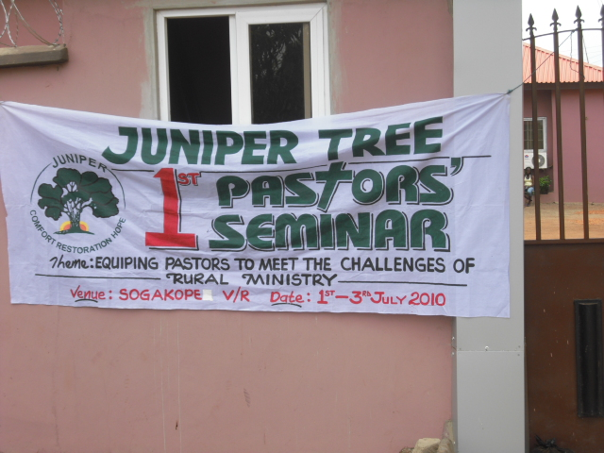
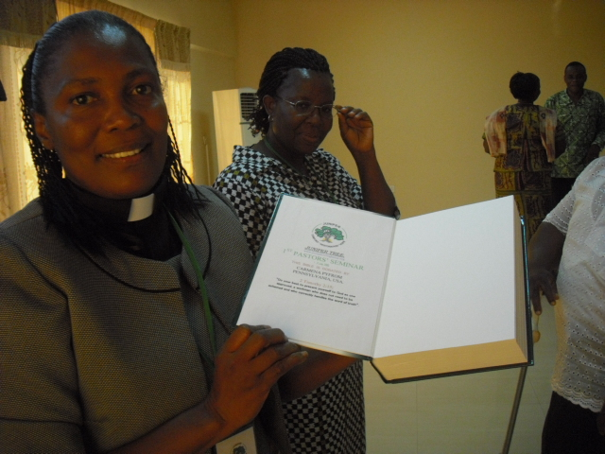
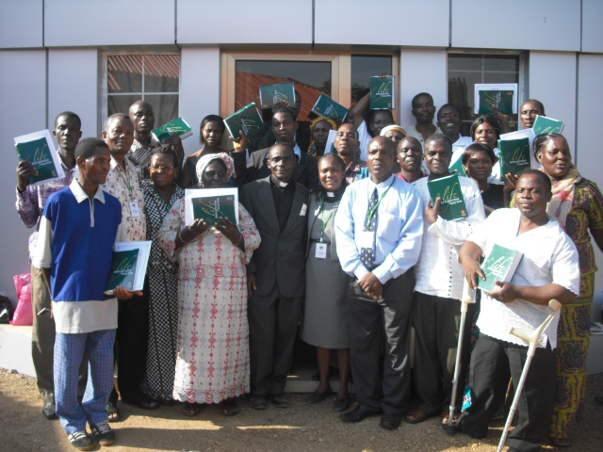
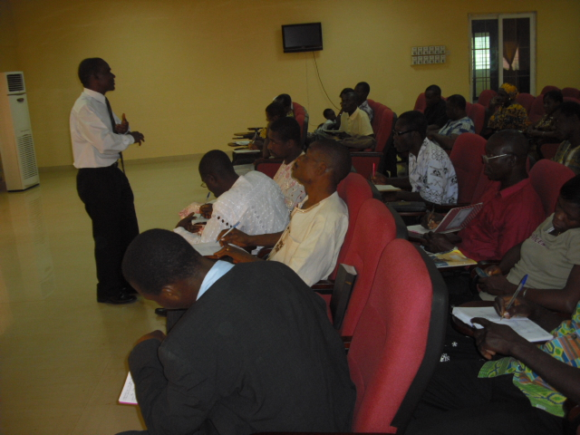
Some Pictures on the first Pastor’s Seminar Held at Sogakope.

2.2 CASES HANDLED: Again the core business of Juniper Tree was the counselling cases.
YEAR/CASES HANDLED | 2008 | 2009 | 2010
# of New Cases handled | 10 | 6 | 15
# of Counselling Sessions | 34 | 15 | 38
# of Counselling sessions from previous year |  | 17 | 5
# of Depression/suicidal ideation issues | 2 |  | 7
#of Sexual Issues | 2 | 4 | 6*
# of Premarital cases |  | 1
# of Misc Issues Self Esteem/relational/ACADEMIC |  |  | 7
# of Marriage cases | 2 | 1
Referred by Medical Personnel | 2 | 1 | 1
Referred by school authorities |  | 2 | 3
Referred by Friends / church/family members | 3 | 2 | 9
Referred by Self | 5 | 2 | 3
TOTAL # OF COUNSELLING SESSIONS |  | 32 | 43

* For five (5) of these cases sexual abuse is an underlining issue.
  - A total of 15 new cases were handled during the year. These cases represented a total of 38 counselling sessions. Categories of cases handled are 7 depression and suicidal ideation. 1 sexual issue. Out of these cases, 3 were self referrals 1 was from medical personnel, 9 were referred by friends or church members and 1 was a referral from a school. There were 5 counselling sessions from the 2009 cases. Making a total of 43 counselling sessions in 2009.
8.0. PROJECTIONS FOR 2011
  - Juniper Tree will continue to formalize collaborations with various organizations and seek new ones.
  - Hold an international Conference on the “Trauma of Abuse of Women and Children – A societal Response” in July
  - Research on Psycho Social Services available to victims of Abuse.
  - Work on Proposals for funding of various projects
  - The Budget proposal for 2011 is attached.
- CONCLUSION:
This has been the year of launching out. We are praying that next year we will take flight. We are grateful to God, for a successful year and to the Board of Directors. Every member of our board donated so generously their time and resources.

JUNIPER TREE BUDGET PROPOSAL FOR 2011
 | Estimated Cost
Administrative/Overhead Expenses
Stationery | 250
Telephone | 1200
Subscription & Dues | 500
Rent | 1200
Board meetings | 3000
Seminars & Meetings | 2500
Postage & Courier | 100
Utilities (Water & Electricity, internet) | 600
Estate Maintenance | 1000
Sub Total | 8350
Project Expenses
Project A - JT School of Counselling | 5000
Project – B International Conference on Trauma and Abuse | 40.000
Website Development/maintenance | 1000
Publications | 1000
Fees for Grant Writing | 3000
Bank Charges | 300
Audit fees | 500
T&T | 5000
Sub Total | 59.800
Personnel Remuneration
Executive Director/Counsellor | 18000
Allowances for PT Counsellors | 6000
Administrative Clerk (PT) | 3600
Driver (PT) | 3600
Personnel Development | 2000
Sub Total | 27.200
Msc
First Aid Kit | 100
Welfare Fund | 400
Sub Total | 500
Grand Total | 98,850

